Mathematics: Applications Glossary
This glossary is provided to enable a common understanding of the key terms in this syllabus.

Unit 1
Consumer arithmetic
Compound interest | The interest earned by investing a sum of money (the principal) is compound interest if each successive interest payment is added to the principal for the purpose of calculating the next interest payment.  For example, if the principal $P$ earns compound interest at the rate of $i$ % per period, then after n periods the total amount accrued is $P{(1+\frac{i}{100})}^{n}$. When plotted on a graph, the total amount accrued is seen to grow exponentially.
CPI | The Consumer Price Index (CPI) is a measure of changes, over time, in retail prices of a constant basket of goods and services representative of consumption expenditure by resident households in Australian metropolitan areas.
Government allowances and pensions | The appropriate government allowances and pensions to consider include allowances for youth, tertiary study and travel. The emphasis is on researching, determining and calculating amounts of allowances and pensions considered appropriate for students, depending on interests, needs, backgrounds and location. Detailed knowledge of conditions of eligibility etc. are not required.
GST | The GST (Goods and Services Tax) is a broad sales tax of 10% on most goods and services transactions in Australia.
Price to earnings ratio (of a share) | The price to earnings ratio of a share (P/E ratio) is defined as :  $$P/Eratio=\frac{Market price per share}{Annual earnings per share}$$
Simple interest | Simple interest is the interest accumulated when the interest payment in each period is a fixed fraction of the principal. For example, if the principle $P$ earns simple interest at the rate of $i$ % per period, then after $n$ periods the accumulated simple interest is $nP\frac{i}{100}$  When plotted on a graph, the total amount accrued is seen to grow linearly.
Algebra and matrices
Algebra
Linear equation | A linear equation in one variable $x$ is an equation of the form  $ax+b=0$, for example, $3x+1=0$.  A linear equation in two variables for example, $x$ and $y$ is an equation of the form  $ax+by+c=0$, for example, $2x-3y+5=0$.

Matrices
Addition of matrices | If $A$ and $B$ are matrices of the same size (order) and the elements of $A$ are $a_{ij}$ and the elements of $B$ are $b_{ij}$, then the elements of $A+B$ are $a_{ij}+b_{ij}$  For example, if $A=$ SHORT ANSWER QUESTIONS Error! Bookmark not defined.  SHORT ANSWER QUESTIONS Error! Bookmark not defined.  and $B$= SHORT ANSWER QUESTIONS Error! Bookmark not defined.  SHORT ANSWER QUESTIONS Error! Bookmark not defined.  then $A+B=$ SHORT ANSWER QUESTIONS Error! Bookmark not defined.  SHORT ANSWER QUESTIONS Error! Bookmark not defined.
Elements (entries) of a matrix | The symbol $a_{ij}$ represents the ($i,j$) element occurring in the ${i }^{th}$row and the ${j }^{th}$ column.  For example, a general 3 × 2 matrix is:  SHORT ANSWER QUESTIONS Error! Bookmark not defined.  SHORT ANSWER QUESTIONS Error! Bookmark not defined.  where $a_{32}$ is the element in the third row and the second column.
Identity matrix | A multiplicative identity matrix is a square matrix in which all of the elements in the leading diagonal are 1’s and the remaining elements are 0’s. Identity matrices are designated by the letter $I$.  For example,  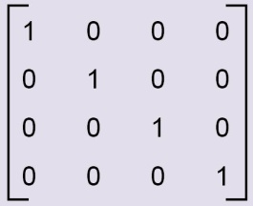  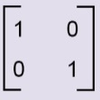  and are both identity matrices.  There is an identity matrix for each size (or order) of a square matrix. When clarity is needed, the order is written with a subscript: $I_{n}$
Leading diagonal | The leading diagonal of a square matrix is the diagonal that runs from the top left corner to the bottom right corner of the matrix.
Matrix (matrices) | A matrix is a rectangular array of elements or entities displayed in rows and columns.  For example,  $A$ = SHORT ANSWER QUESTIONS Error! Bookmark not defined.  SHORT ANSWER QUESTIONS Error! Bookmark not defined.  and $B$ = SHORT ANSWER QUESTIONS Error! Bookmark not defined.  SHORT ANSWER QUESTIONS Error! Bookmark not defined.  are both matrices with six elements.  Matrix $A$ is said to be a 3 × 2 matrix (three rows and two columns) while $B$ is said to be a 2 × 3 matrix (two rows and three columns).  A square matrix has the same number of rows and columns.  A column matrix (or vector) has only one column.  A row matrix (or vector) has only one row.

Matrix multiplication | Matrix multiplication is the process of multiplying a matrix by another matrix.  For example, forming the product  SHORT ANSWER QUESTIONS Error! Bookmark not defined.  SHORT ANSWER QUESTIONS Error! Bookmark not defined.  SHORT ANSWER QUESTIONS Error! Bookmark not defined.  SHORT ANSWER QUESTIONS Error! Bookmark not defined.  = SHORT ANSWER QUESTIONS Error! Bookmark not defined.  SHORT ANSWER QUESTIONS Error! Bookmark not defined.  The multiplication is defined by  1 × 2 + 8 × 0 + 0 × 1 = 2  1 × 1 + 8 × 3 + 0 × 4 = 25  2 × 2 + 5 × 0 + 7 × 1 = 11  2 × 1 + 5 × 3 + 7 × 4 = 45  This is an example of the process of matrix multiplication.  The product $AB$ of two matrices $A$ and $B$ of size $m×n$ and $p×q$ respectively is defined if $n=p$.  If n = p the resulting matrix has size m × q.  If $A$ = SHORT ANSWER QUESTIONS Error! Bookmark not defined.  SHORT ANSWER QUESTIONS Error! Bookmark not defined.  and $B$ = SHORT ANSWER QUESTIONS Error! Bookmark not defined.  SHORT ANSWER QUESTIONS Error! Bookmark not defined.  then $AB$ = SHORT ANSWER QUESTIONS Error! Bookmark not defined.  SHORT ANSWER QUESTIONS Error! Bookmark not defined.
Order (of a matrix) | See Size (of a matrix)
Scalar multiplication (matrices) | Scalar multiplication is the process of multiplying a matrix by a scalar (number).  For example, forming the product  10 SHORT ANSWER QUESTIONS Error! Bookmark not defined.  SHORT ANSWER QUESTIONS Error! Bookmark not defined.  = SHORT ANSWER QUESTIONS Error! Bookmark not defined.  SHORT ANSWER QUESTIONS Error! Bookmark not defined.  is an example of the process of scalar multiplication.  In general, for the matrix $A$ with elements $a_{ij}$, the elements of $kA$ are ${ka}_{ij}$
Size (of a matrix) | Two matrices are said to have the same size (or order) if they have the same number of rows and columns. A matrix with $m$ rows and $n$ columns is said to be a $m×n$ matrix.  For example, the matrices  SHORT ANSWER QUESTIONS Error! Bookmark not defined.  SHORT ANSWER QUESTIONS Error! Bookmark not defined.  and SHORT ANSWER QUESTIONS Error! Bookmark not defined.  SHORT ANSWER QUESTIONS Error! Bookmark not defined.  have the same size. They are both 2 × 3 matrices.
Zero matrix | A zero matrix is a matrix if all of its entries are zero. For example:  SHORT ANSWER QUESTIONS Error! Bookmark not defined.  SHORT ANSWER QUESTIONS Error! Bookmark not defined.  and SHORT ANSWER QUESTIONS Error! Bookmark not defined.  SHORT ANSWER QUESTIONS Error! Bookmark not defined.  are zero matrices.
Shape and measurement
Area of a triangle | The general rule for determining the area of a triangle is:  $$area=\frac{1}{2} base ×height$$
Heron’s rule | Heron’s rule is a rule for determining the area of a triangle, given the lengths of its sides.  The area $A$ of a triangle of side lengths $a$, $b$ and $c$ is given by  $A=\sqrt{s(s-a)(s-b)(s-c)}$ where $s=\frac{1}{2}(a+b+c)$.
Scale factor | A scale factor is a number that scales, or multiplies, some quantity. In the equation $y=kx$, $k$ is the scale factor for $x$.  If two or more figures are similar, their sizes can be compared. The scale factor is the ratio of the length of one side on one figure to the length of the corresponding side on the other figure. It is a measure of magnification; the change of size.
Unit 2
Univariate data analysis and the statistical investigation process
Categorical variable | A categorical variable is a variable whose values are categories.  Examples include blood groups (A, B, AB or O) or house construction type  (brick, concrete, timber, steel, other).  Categories may have numerical labels, for example, the numbers worn by players in a sporting team, but these labels have no numerical significance. They merely serve as labels.
Categorical data | Data associated with a categorical variable is called categorical data.
Continuous data | Data associated with a continuous variable is called continuous data.
Continuous variable | A continuous variable is a numerical variable that can take any value that lies within an interval. In practice, the values taken are subject to the accuracy of the measurement instrument used to obtain these values.  Examples include height, reaction time, and systolic blood pressure.
Discrete data | Discrete data is data associated with a discrete variable. Discrete data is sometimes called count data.
Discrete variable | A discrete variable is a numerical variable that can take only integer values.  Examples include the number of people in a car, the number of decayed teeth in 18 year old males and so on.
Five-number summary | A five-number summary is a method of summarising a set of data using the minimum value, the lower or first-quartile (Q₁), the median, the upper or  third-quartile (Q₃) and the maximum value. Forms the basis for a box-plot.
Location | Location is the notion of central or ‘typical value’ in a sample distribution.  See also mean, median and mode.
Mean | The arithmetic mean of a list of numbers is the sum of the data values divided by the number of values in the list.  In everyday language, the arithmetic mean is commonly called the average.  For example, for the following list of five numbers 2, 3, 3, 6, 8, the mean equals  $\frac{2+3+3+6+8}{5}=\frac{22}{5}=4.4$  In more general language, the mean of $n$ observations $x_{1}$, $x_{2}$,..., $x_{n}$ is $\overline{x}=\frac{\sum{x_{i}}}{n}$
Median | The median is the value in a set of ordered data values that divides the data into two parts of equal size. When there are an odd number of data values, the median is the middle value. When there is an even number of data values, the median is the average of the two central values.
Mode | The mode is the most frequently occurring value in a data set.
Normally distributed data | Normally distributed data is associated with a continuous variable which forms the characteristic bell-shaped distribution. The mean and standard deviation of such a continuous data set are key parameters determining the shape of the underlying distribution of the data set.
Outlier | An outlier in a set of data is an observation that appears to be inconsistent with the remainder of that set of data. An outlier is a surprising observation.
Standard deviation | The standard deviation is a measure of the variability, or spread, of a data set. It gives an indication of the degree to which the individual data values are spread around their mean. Calculation of standard deviation may be done via the use of appropriate technology.
Statistical investigation process | The statistical investigation process is a cyclical process that begins with the need to solve a real-world problem and aims to reflect the way statisticians work. One description of the statistical investigation process in terms of four steps is as follows.  Step 1. Clarify the problem and formulate one or more questions that can be answered with data.  Step 2. Design and implement a plan to collect or obtain appropriate data.  Step 3. Select and apply appropriate graphical or numerical techniques to analyse the data.  Step 4. Interpret the results of this analysis and relate the interpretation to the original question; communicate findings in a systematic and concise manner.  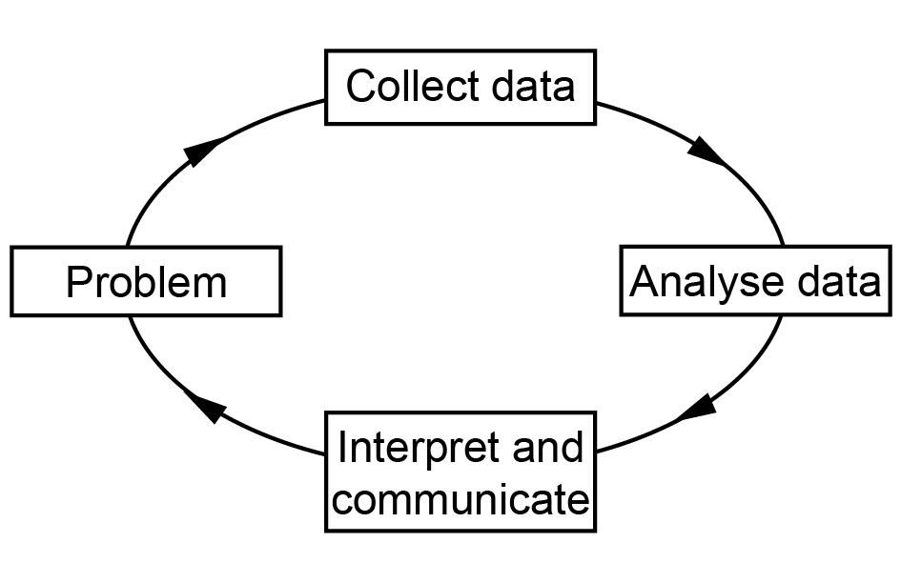
Applications of trigonometry
Angle of elevation | The angle a line makes above a plane.
Angle of depression | The angle a line makes below a plane.
Bearings (compass and true) | A bearing is the direction of a fixed point, or the path of an object, from the point of observation.  Compass bearings are specified as angles either side of north or south. For example, a compass bearing of N50°E is found by facing north and moving through an angle of 50° to the east.  True (or three figure) bearings are measured in degrees from the north line. Three figures are used to specify the direction. Thus the direction of north is specified as 000°, east is specified as 090°, south is specified as 180°, and north-west is specified as 315°.
Cosine rule | For a triangle of side lengths $a$, $b$ and $c$ and angles $A$, $B$ and $C$, the cosine rule states that  $c^{2}=a^{2}+b^{2}-2ab\cos{C}$
Sine rule | For a triangle of side lengths $a$, $b$ and $c$ and angles $A$, $B$ and $C$, the sine rule states that  $\frac{a}{sinA}=\frac{b}{sinB}=\frac{c}{sinC}$
Triangulation | Triangulation is the process of determining the location of a point by measuring angles to it from known points at either end of a fixed baseline, rather than measuring distances to the point directly. The point can then be fixed as the third point of a triangle with one known side and two known angles.
Linear equations (relations) and graphs
Break-even point | The break-even point is the point at which revenue begins to exceed the cost of production.
Linear graph | A linear graph is a graph of a linear equation with two variables. If the linear equation is written in the form $y=a+bx$, then $a$ represents the $y$-intercept and $b$ represents the slope (or gradient) of the linear graph.
Piece-wise-linear graph | A piece-wise-linear graph consisting of one or more non-overlapping line segments. Sometimes called a line segment graph.  Example:  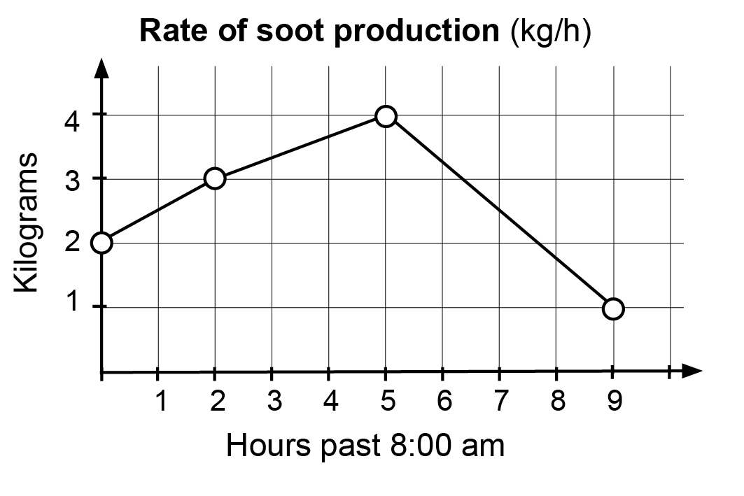
Slope (gradient) | The slope or gradient of a line describes its steepness, incline, or grade.  Slope is normally described by the ratio of the ‘rise’ divided by the ‘run’ between two points on a line.  See also Linear graph.
Step graph | A graph consisting of one or more non-overlapping horizontal line segments that follow a step-like pattern.  